Total risk ratings: Form 07
Instructions:
- See ppt and workbook for examples
- Based on ranking given each subsection above from highest to lowest place the information in the table below.
- The sections are not listed here, just the subsections
- Delete yellow highlighted text and do a save as to your workpapers.

RISK ASSESSMENT
SOURCE OF RISK | LIKELIHOOD OF OCCURRENCE | IMPACT OF OCCURRENCE | 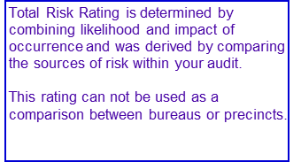  TOTAL RISK RATING
 | (H = High M = Medium L = Low)
1
2
3
4
5
6
7
8
EXAMPLE: Minimum Staffing | L | H | L/H

